**Serving Store-Bought Combination Foods on the CACFP**

A Store-Bought Combination Food is any store-bought food product that combines two or more menu components in a single food item. Chicken nuggets, tenders, fish sticks, corn dogs, pizza, beef ravioli and vegetable beef stew are just a few common example of store-bought combination foods, there are many more.

In order to serve a Store-Bought Combination Food, it must contain the following acceptable documentation**:**

* A Store-Bought Combination Food Product must contain either a **Child Nutrition** **(CN)** label on the package.
* A provider can also obtain a **Product Formulation Statement** **(PFS)** from the manufacturer.

**No** part of the product can be claimed for reimbursement without these types of product identification.

* A provider can send documentation to the Food Program Office or seek approval by your Nutrition Specialist before serving a Store-Bought Combination Food Product.
* If you obtain documentation for a product, keep it on file in your home.



**The CN label includes**:

* Statement of the product's contribution toward meal pattern requirements
* 6-digit product identification number
* Statement specifying that the use of the CN label was authorized by FNS
* Month and year of approval

**Child Nutrition Label** (**CN Label**)**:** a product label may be found on any Store-Bought Combination Food.

To meet the CACFP Meal Requirement it is necessary to serve the proper quantities of each food component. A CN label will show how much meat or meat alternative, grain, fruit or vegetable are found in a product.

The USDA Food and Nutrition Service (FNS) administers the Child Nutrition (CN) labeling program for food companies. The CN label states a product's contribution toward the CACFP meal pattern requirements. CN labeled products, such as pizza, breaded meat and poultry products, are usually packaged in bulk quantities for food service operations. They are seldom available in typical food stores.

|  |  |
| --- | --- |
|  |  |

**Product Formulation Statement (Product Analysis Sheet)**: provides information regarding the product and whether it meets the standards needed to meet the CACFP Meal Requirements. Information sheets can be obtained from the manufacturer with a detailed explanation of what the product actually contains and the amount of each ingredient by weight. Your Nutrition Specialist or Food Program Manager can assist in answering questions regarding commercially prepared food products and/or product analysis. See example below:

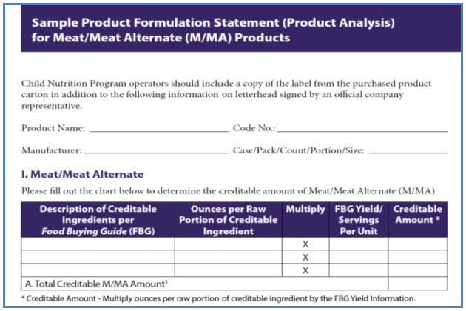

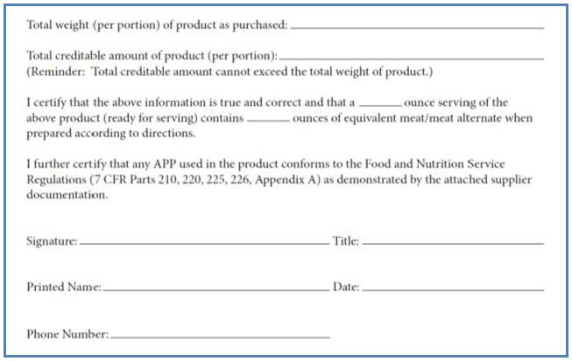

**Important Reminder regarding serving Store-Bought Combination Food Products on the CACFP: No** part of a Store-Bought Combination Food Product can be served without proper documentation and approval from the Food Program, prior to serving. Store-Bought Combination Food Products cannot be claimed on menus for reimbursement on the Food Program.

**Questions?** Do not hesitate to contact the Food Program with questions. Contact your Nutrition Specialist or the 4-C Food Program (608) 271-5242, 1-800 292-2429. [foodprog@4-c.org](mailto:foodprog@4-c.org).

A great alternative to serving combination food products is to make homemade versions.

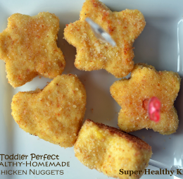**Make Your Own Chicken Nuggets**1/2-pound chicken breast  
1 large egg  
1 dash salt  
1/2 cup bread crumbs, plain  
2 tablespoon butter, unsalted, melted  
2 tablespoon honey mustard dressingBoil five ounces of chicken breast for 20 minutes in water. In a blender, blend together cooked chicken breast, 1 egg and salt. Pack small balls of the meat mixture into cookie cutters, and roll in bread crumbs.  Or make meat mixture into small balls and roll in bread crumbs.  Shapes are optional. Place shapes (or balls) onto a cookie sheet.  Drizzle with a little butter to make them crispier. Bake at 400 degrees for about 10 minutes.  Flip halfway through if you want both sides crispy. Dip in your favorite dip, like ketchup, honey mustard, BBQ sauce, or Ranch Dressing.

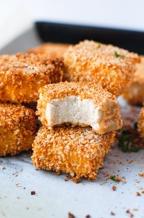**Crispy Baked Tofu Nuggets**

32 ounces – Tofu, firm

1/4 cup – olive oil

1/2 cup – white flour, whole wheat

1/2 cup – Cornmeal

1 teaspoon salt

1/4 teaspoon garlic powder

1/2 teaspoon – onion powder

Preheat oven to 400 degrees and line a baking sheet with parchment paper or a silicone mat. Drain the blocks of tofu, and cut each block into six rectangular slabs. Pat the slabs with a towel until they are good and dry, then cut each slab in half twice to make four Nuggets per slab. Pour the olive oil into a medium-sized mixing bowl, and set aside. In a gallon freezer bag, combine the whole wheat flour, cornmeal, salt, garlic powder, onion powder, and in batches, dunk nuggets into olive oil, then add them to the bag and shake until they're well coated. Arrange the nuggets close together on your baking sheet. Bake for 20 minutes, flip, and then bake 15 minutes more. Serve with ketchup, barbecue, or your favorite sauce for dipping.

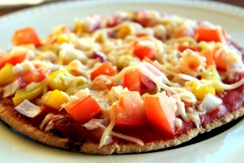 **Easy Pita Pizza**6 - Small Pita Pockets (can be Whole Wheat or White pitas)   
Pizza sauce  
Mozzarella cheese  
Pizza Toppings of choice

Preheat oven at 375 degrees and line a baking sheet with parchment or silicone mat. Split pitas. Allow each child to assemble their own pita with assistance. Place on baking sheet and bake until cheese is melted. Cool briefly and serve.